**Workbench Security Data Addition, Report Generation & Download**

Firstly we need to upload our data and model in model-details docs.

**Step-1:**

url: [**https://rai-toolkit-dev.az.ad.idemo-ppc.com/v1/workbench/docs#/**](https://rai-toolkit-dev.az.ad.idemo-ppc.com/v1/workbench/docs#/)

**Upload Dataset:**

Please go to the "adddata" API at the URL mentioned above and Add Data EndPoint will be this.

Attached is the requested payload below.

**userId** : The "userId" parameter, which corresponds to the "usecase_name."

**Payload**:

**dataFileName**: The "dataFileName" field should contain the name of your data file.

**dataType**: The "dataType" field should specify the type of data, such as "tabular" ,”image” ,"text," based on the dataset.

**groundTruthClassNames**: "groundTruthClassNames" typically refers to the classes or categories present in a dataset, particularly in supervised learning tasks where the data is labeled. For example, in a dataset of images of fruits categorized into apples, bananas, and oranges, "apple," "banana," and "orange" would be the ground truth class names. This information helps in training machine learning models to correctly classify or predict the data. If the dataset contains class labels, they would be listed in the "groundTruthClassNames" field. If there are no class labels or categories in the dataset, this field would be left empty.

**groundTruthClassLabel**: Mention the target column name that your model is going to predict.

**DataFile**: Please select and upload the dataset file by browsing your device.

After entering all the necessary data, proceed by clicking on "execute."

If the information is successfully saved in the database, you will receive a response stating "Data added successfully.

To retrieve the details of the uploaded data, please navigate to the following API. You will receive information such as dataId and name etc.



**Step-2:**

url: [**https://rai-toolkit-dev.az.ad.idemo-ppc.com/v1/workbench/docs#/**](https://rai-toolkit-dev.az.ad.idemo-ppc.com/v1/workbench/docs#/)

**Model Upload:**

Please access the "addmodel" API at the provided URL and Add Model EndPoint will be this.



The requested payload is attached below

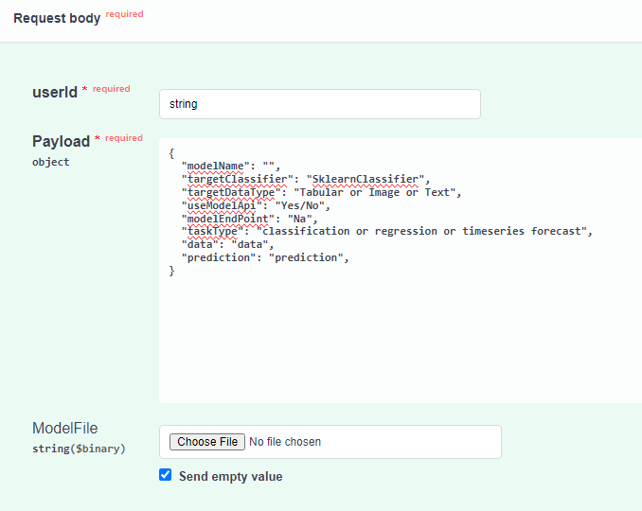

**userId** : The "userId" parameter, which corresponds to the "user_name."

**Payload**:

**modelName** : The "modelName" field should contain the name you choose for your model.

**targetDataType**: The "targetDataType" field should specify the type of data your model is designed to work with such as "tabular" , “image” , "text" based on the dataset it will be trained on.

**taskType**: The "taskType" field should specify the type of task your model is intended for. You can provide "CLASSIFICATION" if the model is for classification tasks, "REGRESSION" if it's for regression tasks, or "TIMESERIESFORECAST" if it's for time series forecasting.

**targetClassifier**: It is type of algorithm which is used to train the model.

**useModelApi**: If you are uploading the model, please provide "**No**." Otherwise, if you are providing the model via an endpoint, provide "**Yes**."

If "**useModelApi**" is set to "**Yes**":

**modelEndpoint**: If you are accessing the model via an endpoint, please specify your endpoint here in the "modelEndpoint" field.

**data**: If you are accessing the model via an endpoint, the "data" field should contain the input parameter of the endpoint, which binds input data to the endpoint.

**prediction**: If you are accessing the model via an endpoint, the "prediction" field should contain the output parameter of the endpoint, which delivers data from the endpoint.

**ModelFile:** Please ignore this field.

If "**useModelApi**" is set to "**No**":

In this case, you can either remove these three fields or leave them as they are:

* modelEndpoint
* data
* prediction

**ModelFile**: Please select and upload the model file by browsing your device.

After entering all the necessary data, click on "execute."

If the model is successfully saved in the database, you will receive a response stating "Model added successfully."

To retrieve the details of the uploaded model, please navigate to the following API. You will receive information such as modelId and name etc.



**Step-3:**

**List of applicable attacks:**

url: [**https://api-aicloud.ad.infosys.com/rai/v1/security_workbench/docs#/**](https://api-aicloud.ad.infosys.com/rai/v1/security_workbench/docs#/)

It is the list of applicable attacks which can be run on your provided model. To check which attacks is applicable, you have to provide classifier and data type to below api endpoint of above mention url.

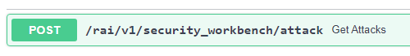

The requested payload is attached below

**TargetClassifier :** It is type of algorithm which is used to train the model like SklearnClassifier, KerasClassifier etc.

**TargetDataType :** It refer to the nature or format of the input features that are used to train a model like tabular,image or text.

**Response :**

This is the list of applicable attacks on SklearnClassifier and tabular data.

**Step-4:**

url: [**https://rai-toolkit-dev.az.ad.idemo-ppc.com/v1/workbench/docs#/**](https://rai-toolkit-dev.az.ad.idemo-ppc.com/v1/workbench/docs#/)

**Batch Generation:**

Please access the "batchgeneration" API at the provided URL and EndPoint will be this.

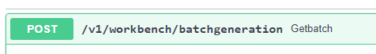

The requested payload is attached below

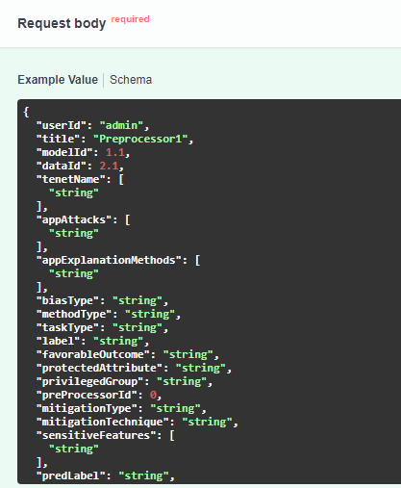

**userId** : The "userId" parameter, which corresponds to the "user_name."

**modelId**: You will obtain the "modelId" from the "get models" API. (/v1/workbench/model).

**dataId**: You will obtain the "dataId" from the "get datas" API. (/v1/workbench/data).

**tenetName**: "Security" is the tenet name.

**appAttacks :** It is the list of applicable attack which we run on our model. You will get it from above provided endpoint in step-3.

You can either remove these fields or leave them as they are:

* title
* appExplanationMethods
* biasType
* methodType
* taskType
* label
* favorableOutcome
* protectedAttribute
* privilegedGroup
* preProcessorId
* mitigationType
* mitigationTechnique
* sensitiveFeatures
* predLabel
* knn

Once you have provided all the necessary data, click on "execute." You will receive the batchId and tenetId as a response.

Copy the batchId and paste it into the below API in the AI Cloud doc to generate the report for the given batchId.

**Step-5:**

**Report Generation:**

url**:** [**https://api-aicloud.ad.infosys.com/rai/v1/security_workbench/docs#/**](https://api-aicloud.ad.infosys.com/rai/v1/security_workbench/docs#/)

We need to pass the batchId as a request to above endpoint, and It will create the report and store it in zip format in the database.

Now that we've created the report as well. Next, we can proceed to download the report.

**Step-6:**

**Report Download:**

url**:** [**https://rai-toolkit-rai.az.ad.idemo-ppc.com/v1/report/docs**](https://rai-toolkit-rai.az.ad.idemo-ppc.com/v1/report/docs)

To download the report, please refer to API Endpoint provided above. Use the same batchId that was used to generate the report.